EVALUATION STEP 4

INVESTIGATING and GATHERING THE RESOURCES

Why choose to start a business?

This is a useful point for you to reflect on how this will change your life at a number of fundamental levels. To read a short extract which considers why choosing to start a business may be the best option follow the link here.
Enterprise option

The enterprise option

People increasingly are considering starting a business as the best - if not only - employment option available. Surveys have shown that in the UK this is expected to be the greatest area of employment growth in future years, building on the increase experienced over the past fifteen years. This growth has occurred for several reasons:
- - an increasing recognition of the value of small/medium sized businesses to the economy;
- - changing patterns of work and downsizing of large organisations, creating opportunities for small niche businesses;
- - more and more young people see starting their own business as a valid career choice;
- - an environment which is encouraging enterprise; and,
- - increasing media interest and thus more general interest.
The real value of encouraging enterprise, however, is not just in direct job creation today. With rapidly changing patterns of work, the concept of lifelong employment is now a thing of the past. Already, in the USA, people expect to change not just their jobs, but their careers, four times during their working lives.

These more varied patterns of work in the future will put a premium on people who are adaptable and resourceful - that is, enterprising. Time spent working for yourself can teach skills such as initiative, responsibility and teamworking. Successful small business owners often prove to be extremely employable.
Thus, experience of running a business will be something which people can use in a variety of ways, such as:

- - an experience which will give additional skills and improve their chances of a job with an employer; and,
- - a career alternative at different periods of their working lives.

Definitions of enterprise

The general assumption is to define ‘enterprise’ in its economic context as a business venture aimed at accruing wealth. A broader definition of enterprise is needed which points out its social and political derivations. This will emphasise self-reliance, self-promotion, etc. It is a spirit of ‘getting up and having a go...’. Enterprise is certainly not to be confined to one ideological area - and is definitely not inimical to the development of community spirit. An enterprise can be a venture, project, or undertaking where the community is the main beneficiary rather than the people running the enterprise, or the organisation of any type of event, e.g. a disco for handicapped people; organising a village outing to a beauty spot; a parents’ action group raising funds for a school, or fund-raising for a political party or a pressure group.
‘Enterprising skills’ will be needed in any of these undertakings and this leads to another, broader definition of ‘enterprise’ - personal attributes, such as the ability to:

- - have ideas - to think laterally;
- - do things differently;
- - take initiatives;
- - be a self-starter; and,
- - get things done.

Thus within this definition would fall those who are personally enterprising, perhaps through starting a business; those who are enterprising within a larger company setting; those who are enterprising in launching or running voluntary initiatives, such as Bob Geldof and Band Aid.

For those who do eventually decide to start their own businesses there will be a spectrum from the one-person business to the potential millionaire. For others, a co-op or community business may group the skills required.

Benefits of enterprise to society

“A society where individuals are encouraged to take control of their lives is a society of freedom and growth.”
Albert Shapero in his article ‘Why Entrepreneurship?’

Enterprise in its broader context can challenge the present economic, political and social systems, and can even lead to improvements in these systems or replace them with a more appropriate alternative because it encourages innovation, initiative, creativity, independence, dynamism and diversity, assuring the continuous development of society. There are clearly benefits to the community through the creation of new businesses and new jobs. The absence of enterprise would result in the stagnation of society as there would be no new ideas.

Enterprise also benefits the individual, as it improves:

- - self-sufficiency;
- - independence;
- - innovation;
- - creativity;
- - communication skills; and,
- - decision making skills.

In addition, it gives people the freedom to make life/work more satisfying, to live life to the full and to take a responsible place in society.

Young people and enterprise

Youth unemployment is affecting increasing numbers of young people who, as a result, feel alienated from the community. There is a need to involve them in the community by encouraging enterprises, whether they are businesses or community ventures. The benefits of encouraging youth enterprise would be of personal value to the young person in acquiring:
- - enterprise skills;
- - enterprise experience;
- - a feeling of responsibility in the community;
- - the recognition and respect of others;
- - confidence; and,
- - the ability to create his/her own job and earn a living

The requirements of a new venture
The requirements of an enterprise may be summed up as follows:
- Initiating ideas - generating the initial proposal
- Research and design - investigating the feasibility of the business proposal and developing it into an enterprise
- Resourcing - funding, obtaining advice and expertise
- Marketing - promoting and selling the enterprise
- Running - administering and operating the enterprise; and,
- Evaluation and feedback - monitoring what is happening in the business and responding appropriately
You are well on the way, having already initiated your own ideas and carried out some research and design tasks. Requirement 3 is all about finding the resources you require to make your enterprise work, before managing these resources effectively.

What resources are required?
List of resources
The resources needed by an enterprise can be classed under five headings:
- Financial - banks, grants, loans;
- Expertise in enterprise - business/technical skills - training courses, legal knowledge, money management;
- Personal support - agencies, counsellors, contacts;
- Premises - renting, leasing; incubation; and,
- Equipment - renting, leasing, etc.
We will look at each of these in more detail, but before doing so it is worth taking a few moments to consider other forms of ‘capital’ that you can draw upon.

Concepts of ‘capital’
In addition to the more tangible forms of resource that you need to gather, remember that other forms of ‘capital’, which you may already possess, will help you turn your enterprise idea into a fledgling business:
- Business capital – those aspects of human endeavour which are directed at effective organisational management.
- Social capital – human endeavour enabling participants to act together more effectively to pursue shared objectives (networking capital)
- Individual capital - individual performance / empowerment through skills, talents, attitudes etc.
- Academic capital – knowledge gained – tacit and explicit.
These types of capital also support the development of a business. Some of this capital you will already have and more can be developed through networks and experience.
A frequent piece of advice given by business support specialists to graduate entrepreneurs is to improve their social and selling skills.

Advice to graduate entrepreneurs
- Don’t be afraid to take good professional advice at all times. Be realistic, be prepared to make mistakes and persevere.
- Seek as much evidence and advice as you can and make sure that you are thoroughly prepared.
- To benefit from professional services you must have understood your objectives, who will buy it (product or service) and how you will fund its development.
- Improve selling skills – self and ideas.

Incubation services

Incubation services are provided to “incubate” or support new businesses as they start. For some enterprises with high growth potential, the ideal solution may well be to set up in an incubator. These provide a mixture of accommodation, business support and sometimes seed funding.

 Activity

Research incubation in your own area.

Look at what your own university offers and at what is available from local development agencies, such as the Regional Development Agency or Business Links.

For an example of a virtual incubation service that is not bound by premises, take a look at what Connect London offers. Click here.
UKBI is the UK professional body for the business incubation industry with over 1000 mebers

Financial resources

Small businesses have a wide range of finance needs giving rise to a number of key financial management issues. The DTI Business Link service provides much useful business support, advice and information, particularly in the area of finding and managing money. The following are particularly relevant.
Get the right finance for your business needs – there are many different types of finance available, each designed to meet different needs. Getting the right type of finance is essential to help your business succeed. The DTI’s Business Link provides an interactive tool designed to help you choose the right type of finance for your business. To link click here.
Grants: the basics – there are grants to help with business development available from a variety of sources, such as government, the EU, Regional Development Agencies, Business Links and some charitable organisations. The DTI’s Business Link provides a guide to introduce some of the grants available and the kinds of projects and organisations they are available to. To link click here.
Loans and overdrafts – there are different sources of borrowing when starting or growing a business. The DTI’s Business Link provides a guide to the two most popular sources of start-up funding – loans and overdrafts. To link click here.
Other sources of financial advice and help
Two other very good resources for finding about business finance are Startups.co.uk and Smarta.com. Both of these websites offer good advice on the types of funding required and where to find it.
Approaching Investors
<question textentry1>
<text>What is the most important source of external finance for small enterprises?</text>

<feedback>The bank loan and overdraft remains by far the largest source of external finance for SMEs. Banks provide just over half of all external finance for small and medium-sized businesses. In recent years there has been a shift away from overdraft lending towards term lending. </feedback>
</question>

For advice on approaching investors and how to ‘pitch’ your business proposition click here.

Investors
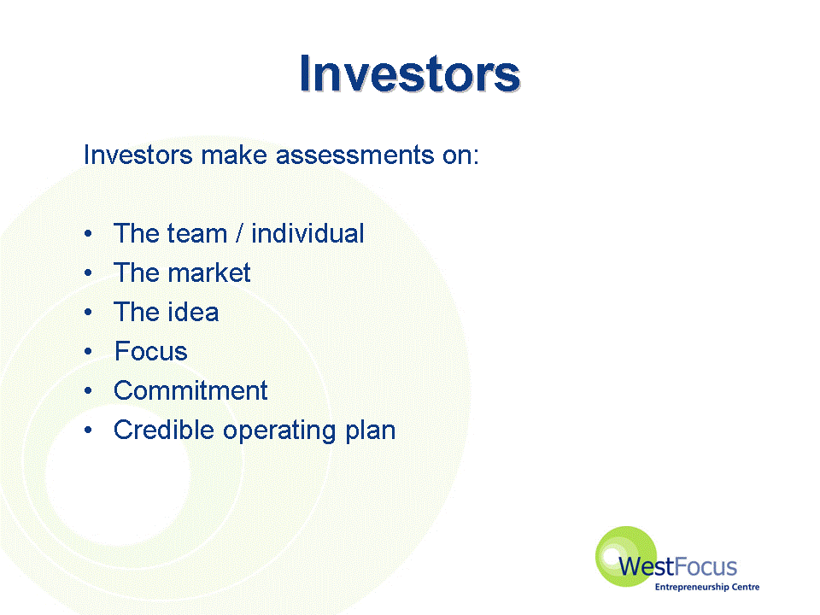
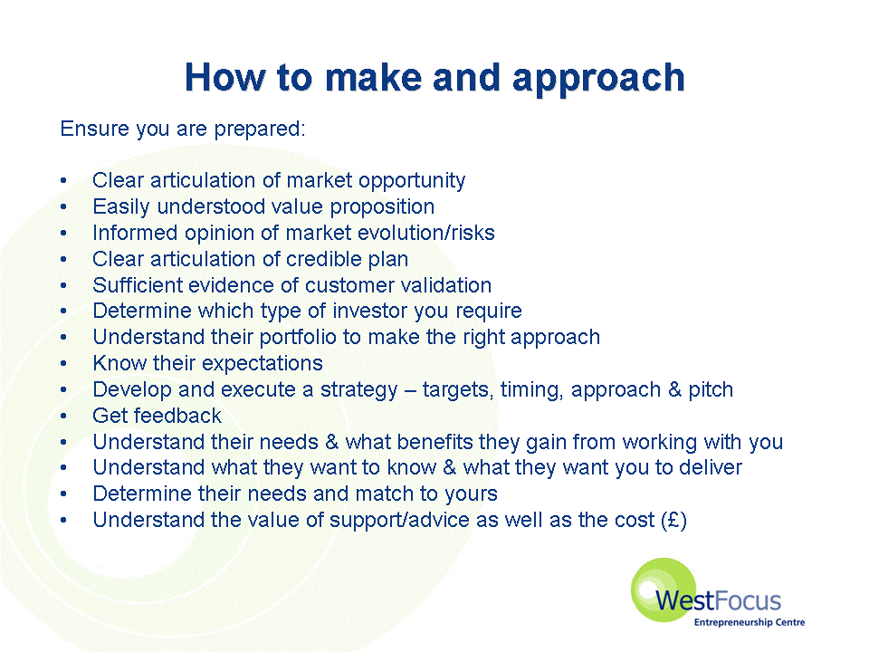
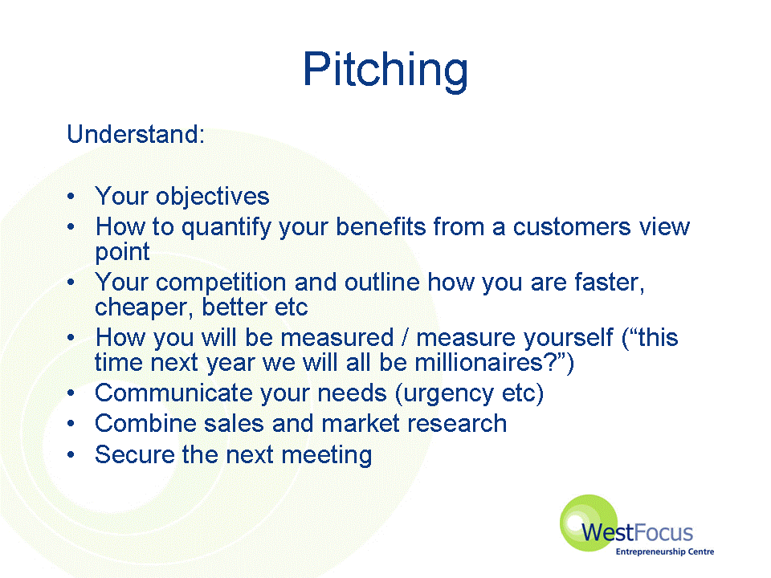

Some key financial terms explained, click here.

Finance terms
Venture Capitalist - a person (usually working for a venture capital company) who invests money into risky but potentially very profitable businesses

Working capital - required to bridge the gap between when a small business gets paid and when it has to pay suppliers and overhead costs

Profit and loss account - shows how a business is doing in terms of sales and costs – and the difference between them of profit or losses

Cash flow - the movement of cash into and out of the business

Balance sheet - a snapshot, representing a summary of what money has been spent by a business, and what it has been spent on. It is usually an annual summary of the use and sources of funds in a company

Business case links

Businesses have to buy all sorts of things to create the goods and services they provide. But there are new ways to think about when financing your start-up or growth opportunity. For example, a new form of bartering allows you to join a network where you can pay in 'Trade Pounds' instead of regular pounds. To read more, click here.

Primal Soup raised the capital they needed to push the brand and move premises through a combination of backers including the London Seed Capital Fund (a state-backed investment project), the Small Firms Loan Guarantee Scheme and financing from Business Angels. To read more, click here.

Business Angels
<question textentry1>
<text>Who are Business Angels and how many of them do you think there might be in the UK?</text>

<feedback>Informal venture capital is supplied by Business Angels - high net worth individuals, often self made, who are interested in investing in entrepreneurial high growth ventures. These individuals rely on informal networking and, in some cases, more formal ‘Business Angel Networks’ (BANs) to identify those businesses that wish to invest in.

No one really knows how many of them there are, but it has been estimated that there are between 20,000 and 40,000 in the UK. The Business Angels themselves are often secretive and invisible to the market. </feedback>
</question>

The Business Angels Network is an organisation that matches angels with companies - a bit like an investment dating agency. For an example of how it operates, click here.

Expertise in enterprise

Most people, even if they have suitable vocational skills, will still have to learn appropriate business skills. Going on a course can be one way of deciding if starting a business is really the right route for you. Why not get involved in some of the entrepreneurship activities going on at your local University, if you aren’t already? To see what one group of universities in south east England are offering click here
And get advice!

- Seek specialist help
- Ask entrepreneurs for advice
- Get into networks
- Contact incubators for contacts
- Contact University support

There are plenty of interesting ‘expertise’ networking opportunities that you might want to explore, such as these two examples:

- Linked In (linkedin.com)
- The Beermat Ecademy (beermat.ecademy.com)

Presenting yourself to professional business advisors
It is one thing to know where to look – another to be able to present yourself and your enterprise effectively. A criticism often made of aspirant entrepreneurs is that they do not have strong enough presentation and selling skills. You may find it useful to have a look through a short presentation which outlines some of the key issues facing how you interact with professional business advisors and how you ‘sell yourself’ under such circumstances. To view the presentation on professional external advisors click here.
External Professionals 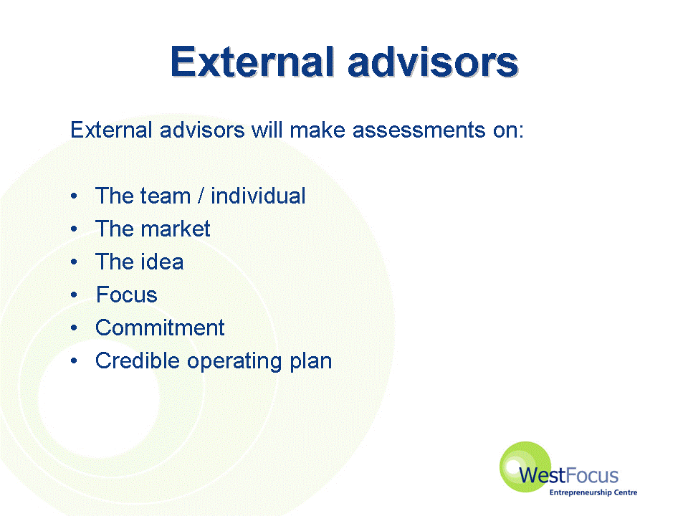
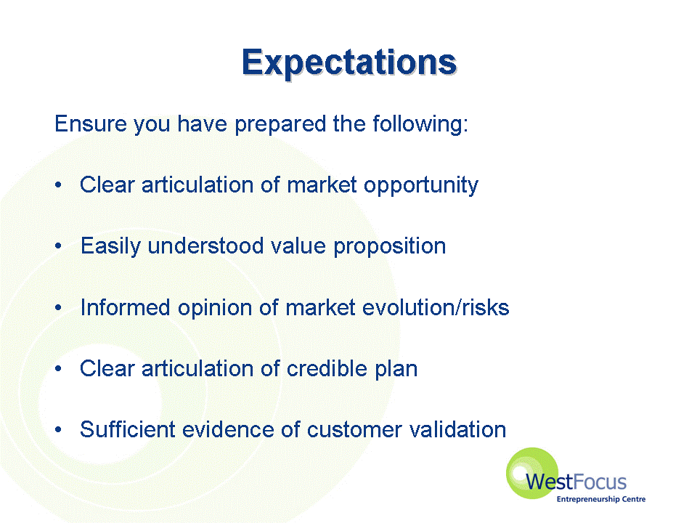
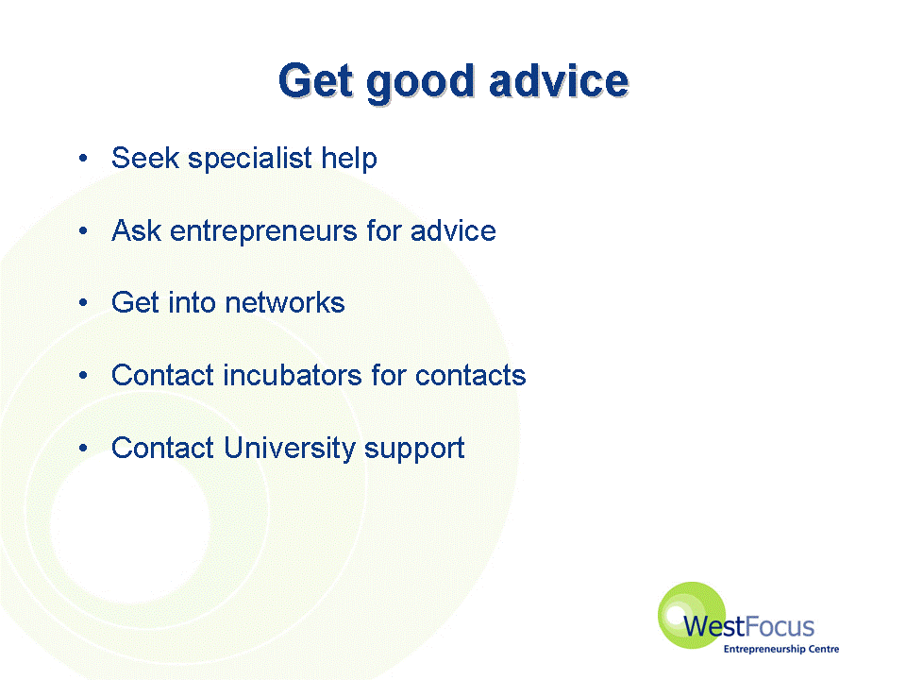
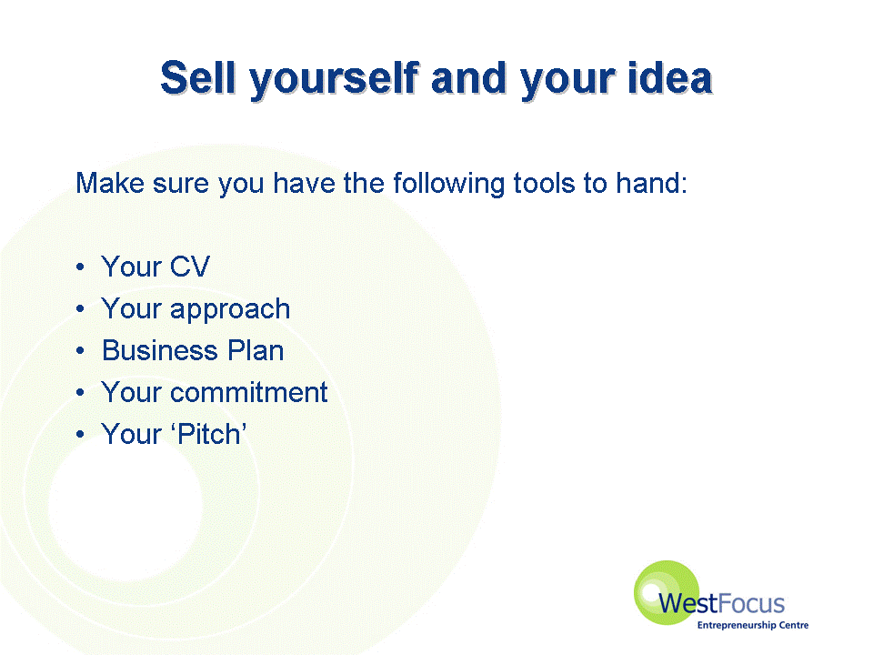
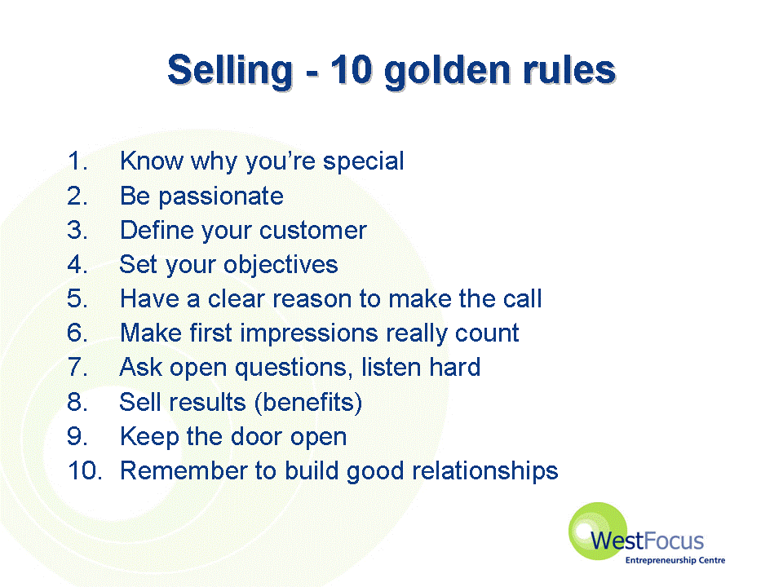
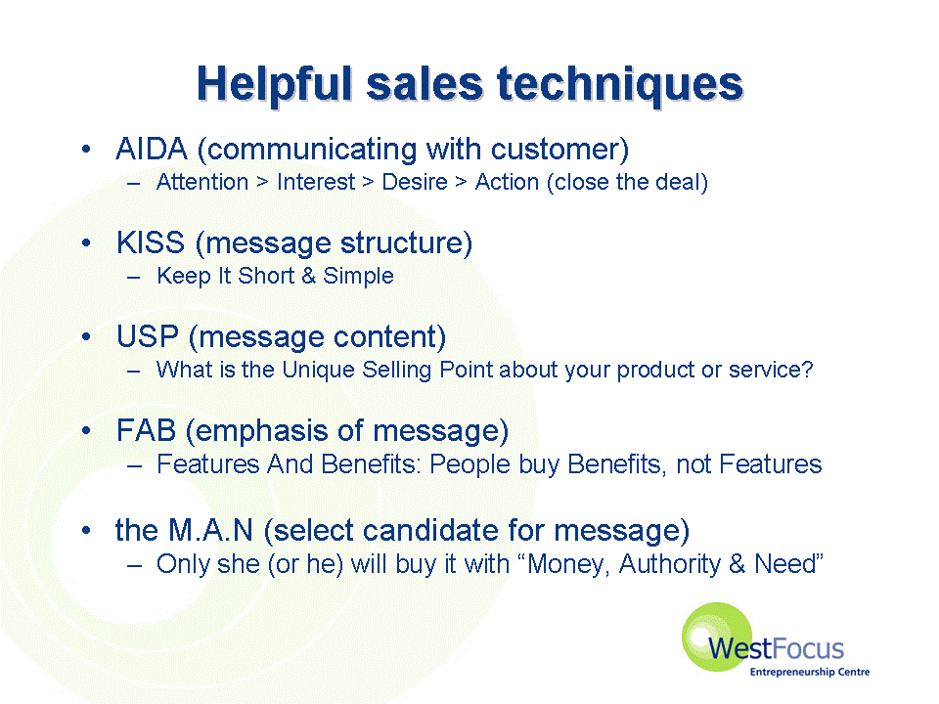

Before an aspiring entrepreneur walks into my office…

A professional grouping were asked to summarise the knowledge, activities, understanding and appreciation that they would like an aspiring entrepreneur to have before engaging with their professional services.

Activity

What would professional advisors expect you to know before you approach them?
Know
Things an aspiring entrepreneur should know when they approach the following professional advisors:

Accountants
What they want to achieve and by when.
About their business idea & the relevant market.

Bankers
The product.
The market and the route to the market.
What they want to achieve.
If they need financial assistance.

Business Support / Professionals (mixed)
Who they are? What they want to do – “expectations”?
Pros and cons of self-employment.
That they do not want to be employed.
Themselves.
Have an idea as to what they want to do.

Entrepreneurs
Its ok to ask questions, even if they are stupid ones.
Why they’re doing it?
It’s there for the taking.

Lawyers
What their idea is?
Their market.
Approximately what costs are involved in setting up a new business.
What they want from us? – What help can we provide?
What would professional advisors expect you to do before you approach them?
Do
Things an aspiring entrepreneur should do when they approach the following professional advisors:

Accountants
Prepare a well-researched proposal to form basis for a business plan.

Bankers
Be prepared to build a comprehensive business plan if finance required.
Follow the advice from BSUs

Business Support / Professionals (mixed)
Be open-ended.
Willing to listen – work hard.
Seek advice.
Hit “Brick walls”
A module on business planning.
Be realistic.
Work experience..

Entrepreneurs
Have an idea.
Retain ownership.
Have done some research.

Lawyers
Have put together a business plan.
Spoken to a bank / arranged finance – spoken to small business advisor.
Have contacted suppliers, customers or identify suppliers / customers.
What would professional advisors expect you to understand before you approach them?
Understand
Things an aspiring entrepreneur should understand when they approach the following professional advisors:

Accountants
The potential risks.
The fundamentals of their chosen business and its marketplace.

Bankers
The bank’s limitations in helping.
Banks are businesses too – they are not charities; we expect a major financial stake from the customer.

Business Support / Professionals (mixed)
We won’t run your business for you – or write your business plan / market research.
The value of market research.
Business.
That free help + advice is there for them to use.

Entrepreneurs
They are the ones that will make it happen.
It’s a long haul.
They have a right to expect good service.

Lawyers
Costs involved in setting up business – legal costs and other specialists costs.
Some of the risks involved – have a general idea – we could pad that information out.
What would professional advisors expect you to appreciate when you approach them?
Appreciate
Things an aspiring entrepreneur should appreciate when they approach the following professional advisors:

Accountants
The total commitment involved.
There is “no gain without pain”
The value of good professional advice.

Bankers
Why the bank needs certain information and how it is used.

Business Support / Professionals (mixed)
Some rules and regulations.
Not on your own.
Taking calculated risks.
Responsibility.
The world does not owe them a living.
That opportunities have risk.
The importance of balancing what they do.
What help is available?
The value of co-operation.
Experience the value of listening.

Entrepreneurs
They may fail.
Things won’t go to plan.
Not all agencies are able to deliver.

Lawyers
Lawyers can offer quality commercial advice, not just legal.

And finally, what don’t professional advisors expect you to know or do when you approach them?

Don’t
Things professional advisors don’t expect you to know or do when you approach them:

Accountants
Know how to fund the business.
Write a formal business plan.
Know how to deal with regulatory matters – the “red tape” introduced by governments!
Keep your books.
Decide on status of the business – company? Partnership? Sole trader?

Bankers
Have all the answers!

Business Support / Professionals (mixed)
Know everything.
How long a business will last.
Understand VAT + legal obligations

Entrepreneurs
Do my job for me.

Personal support

As you may have realised already, setting up an enterprise is a life-changing event. It is bound to be stressful as well as exciting. Having the support and encouragement of friends and family is vital for sustained success. But there are also other people you can contact if you need to. People will often look to their business counsellor or careers officer or adviser for a great deal of support and encouragement, particularly if they have little support from friends or family.

Employing staff

It may well be that you will need to employ some staff to get your new business up and running.

The DTI Business Link has a series of useful guides that cover the basics of how to go about recruiting staff and your obligations as an employer. The following guides will take you through the initial aspects of employing staff:

- Recruitment and getting started
- Paperwork
- Paying your staff

Further aspects of employing staff will be considered in Implementation Step 7.

Premises

In many areas there are ‘managed workspaces’ which are able to provide rented space, often partially subsidised, and a range of common services which may include typing, photocopying, telephone answering, etc. Often counselling and other support services are also available on-site. An example is the Workspace group which is the leading provider of flexible business accommodation to small and medium sized enterprises in London and the South East.
If this sort of space is not available, or is inappropriate, then can the business be started from home? If not, your local enterprise agency will be able to advise on finding premises and on leases.
For useful guides to premises and working from home, see Smarta.com. Click here for their premises advice.
Business case link

For new enterprises, circumstances and finances often mean that there is no option but to start from home. Take a look at the BBC News Working Lunch video link “Many successful businesses have begun in people’s homes”, which you can access by clicking the link here.

Equipment

Try to be innovative around your equipment requirements. Instead of outlaying lots of money on brand-new or even second-hand equipment that you don’t use very often, why not hire or borrow what you can?
Check with the library or ask your business advisor if there is a community resource centre in your area. Perhaps you could hire some of your equipment out and raise lots of money. Why not form or join an equipment pool?

Networking to Leverage your resources

"In business you don't get what you deserve....you get what you negotiate"

You can leverage your resources by doing all you can to get as much for as little as possible! (Sometimes referred to as the ‘parsimonious path’ to entrepreneurship.)
Managing to reach for resources beyond their immediate control is a key skill of the entrepreneur. In attempting to achieve something new it is difficult to ensure that you will have all the resources needed when you start out. Instead you will need to use skill and ingenuity to find the resources you need to achieve your vision. In a new venture, gathering resources is the priority. As a firm grows, the balance changes to resource deployment – i.e. building the organisation’s ability to create value.

For example: Perhaps you manage to secure a small grant for your new enterprise. In this case, it may well be that you can leverage this small investment in your new venture to persuade another investor (perhaps a bank or business angel) to pitch in too. After all, people often need the re-assurance that they are not the only ones investing in a new and potentially risky venture.

Business case link

Anne Mackenzie-Hunt’s business start-up, Not Just Pink and Blue, faced an initial resource problem in getting hold of something to sell. Buying stock turned out to be "a very steep learning curve". To read more, click here.

A great way to find additional resources is through networking. There are many networks specific to business start up. Many of the websites we have been linking you to such as Smarta.com and Startups.co.uk have networks attached to them. There are many others:
- Business Junction – a London Business network
- Entrepreneur Connect – run by the magazine ‘Entrepreneur’
- Mashable.com – a social media guide that gives its opinion on the top 10 social networks for entrepreneurs
- Striding Out – events, contacts and support for young entrepreneurs

e-tivity (4) - Planning your resources

By now you have established that you have a viable business opportunity. In this e-tivity we start on the road to making your enterprise come alive.

Please, answer the following questions:

Using the list of resources outlined above, assess what resources are currently in your possession, and which you have yet to find.

Which do you anticipate will be the hardest to gather? Why is that? What will be your approach to gathering these resources? For example, map out the contacts you have either directly or through a friend or colleague that can lead you to the human resources you require. [Ideally you should have a mixture of direct ‘strong’ ties (e.g. family or friends) and more indirect ‘weak’ ties (i.e. friends or colleagues of friends).

Draw up a table for each category of resource as indicated below:

Resource type | Specific resources acquired | Specific resources required | Approach to resource gathering
Financial | e.g. small grant (details) | e.g. Bank loan (details inc. financial terms sought) | Resource leveraging (detailed approach)
Expertise

Personal support

Premises

Equipment

Evaluation Step 4: Further links & reading

Stokes, D., Wilson, N., and Mador, M. (2010) Entrepreneurship, Cengage Learning, Chapters 9, 14 and 15.

Stokes, D. and Wilson, N. (2010) Small Business Management and Entrepreneurship edition 6, Cengage Learning, Chapters 5, 7 and 13.

Useful finance sources include:

The Bank of England, Finance for Small Firms.

British Bankers Association

British Business Angels Association

British Venture Capital Association

http://www.barclays.co.uk/commercial/turningthecorner/documents/bank-funding-how-to-guide.pdf - Understanding how banks assess lending opportunities to help maximise chances of getting the funding required.

http://www.sba.gov/smallbusinessplanner/start/financestartup/index.html - worksheets and other resources to help define financial requirements from the US.

More information about AIM can be obtained from the London Stock Exchange

Prince’s Trust ‘Start up in business’ web page

Startups.co.uk – a really useful online resource for finding the resources you need

Smarta.com –online support service for entrepreneurs with lots of advice on finance and other resources

VentureNavigator – free online business support service offering information resources and business assessments for creating and growing a new business.

